

***RISK MANAGEMENT PLAN***

***FOR***

***Residential Communication Channel System***

***Version 1.3***

***Team 2 - GENTLEMAN***

***Revision***

|  |  |  |  |
| --- | --- | --- | --- |
| *Author* | *Version* | *Date* | *Content* |
| *Lam To* | ***1.1*** | *24/10/2018* | *Initiate Document* |
| *Lam To* | ***1.2*** | *25/10/2018* | *Update content document* |
| *Vinh Nguyen* | ***1.3*** | *27/10/2018* | *Review and update document* |

Table of Contents

***1.*** ***Document Overview*** 2

***a.*** ***Purpose*** 2

***b.*** ***Audience*** 2

***2.*** ***Risk Management*** 2

***a.*** ***Process*** 2

***b.*** ***Risk Identify*** 4

***c.*** ***Risk Analysis*** 4

***d.*** ***Risk Analysis - Probability*** 4

***e.*** ***Risk Analysis – Impact*** 4

***3.*** ***Risk Analysis Matrix*** 5

***4.*** ***Risk Response*** 5

***5.*** ***Reference*** 5

1. ***Document Overview***
   1. ***Purpose***
      * This document will define process, set priority, responding, monitoring and miltigate report risk. The Risk Management Plan define risk occur in project and describes how the risk is important and probability of risk will occur in project then we can monitoring and miltigating them.
   2. ***Audience***

|  |  |  |
| --- | --- | --- |
| **Intended Audience** | **Name** | **Reading Suggestions** |
| GENTLEMAN – Team Member | * Manh Truong * Quan Ngo * Hao Vo * Lam To * An Pham | Review Document and report |
| Mentor | * Quoc Nguyen | Review Document |
| Project Manager | * Vinh Nguyen | Initiate and Document Specification |

1. ***Risk Management***
   1. ***Process***



|  |  |  |  |  |
| --- | --- | --- | --- | --- |
| **No.** | **Steps** | **Description** | **Role** | **Output** |
|  | ***Risk Identification*** | Identify a list of possible risks in the project | Project Manager, Team Member | Risk Identified List |
|  | ***Risk analysis*** | Evaluate the likelihood and impact of each risk | Project Manager, Team Member | * + Risk is real or not   + If it is real, how they impact the project ?   + Impact and Probability are Analyzed |
|  | ***Risk Prioritization*** | Evaluate the priority of risk | Project Manager | Risk Prioritized by Risk Exposure |
|  | ***Risk management Planning*** | Make a plan to deal with possible risks | Project Manager, Team Member | Risk Management Log |
|  | ***Risk Resolution*** | Make plans to address possible risks | Project Manager, Team Member | The solution to deal with each risk |
|  | ***Risk monitoring*** | Keep track of current risks and identify new risks | Project Manager | Risk Management Log Updated |

* 1. ***Risk Identify***

Risk Management Log will manage risks can occur for project include: priority, probability, impact and miltigate plan.

Please prefer to RCC_RiskManagementLog.xlxs

* 1. ***Risk Analysis***

Risks will be analyzed on two factors: The probability and extent of impact

* 1. ***Risk Analysis - Probability***

|  |  |  |  |
| --- | --- | --- | --- |
| **No.** | **Probability** | **Status** | **Desctiption** |
| *1.* | 10% | Not Likely | Risks is expected to not occur and can avoid |
| *2.* | 30% | Low Likelihood | Risks is less occur and easy to mitigate |
| *3.* | 50% | Likely | Risks can occur or can’t occur but still mitigate |
| *4.* | 70% | High Likely | Risks is more occur, we must to mitigate |
| *5.* | 90% | Near Certainly | Risk is expected to occur, we must to mitigate as soon as possible. If it occur, we will try to mitigate or plan to accept it. |

* 1. ***Risk Analysis – Impact***

|  |  |  |  |  |  |
| --- | --- | --- | --- | --- | --- |
| **Project Objective** | **Non – Linear Scale** | | | | |
| **Minimal ( 1)** | **Minor (2)** | **Moderate (3)** | **Significant (4)** | **Severe (5)** |
| Schedule | Insignificant Schedule Slippage | Schedule Clip page < 5% | Overall Project Clip page 5-10% | Overall Project Clip page 10-20% | Overall Project Schedule Slips >20% |
| Scope | Scope Decrease Barely Noticeable | Minor Areas of Scope are Affected | Major Areas of Scope are Affected | Scope reduction unacceptable to the Stakeholder | Project end item if Effective useless |
| Quality | Quality Degradation Barely Noticeable | Only Very Demanding Application are Effected | Quality Reduction Requires Stakeholder Approval | Quality Reduction Unacceptable to the stakeholder | Project end item if Effectively Unusable |

1. ***Risk Analysis Matrix***

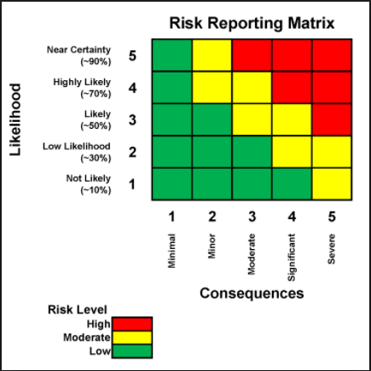

1. ***Risk Response***

We have three solution with risk:

* + - Avoid: Eliminate risk by eliminate the cause
    - Mitigate:

1. ***Reference***

K21T2-Team1-RiskManagement-Plan.docx

ECB_PM_RiskManagementPlan_ver1.0.docx